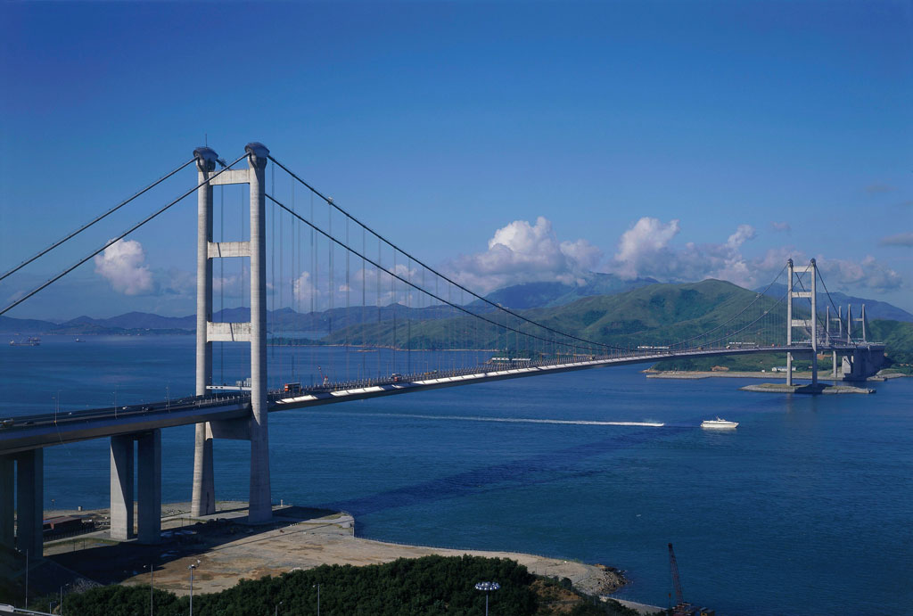**TSING MA BRIDGE**

* **Height:** 206 m (676 ft)
* **Length:** 2160 m (7086 ft)
* **Width:** 41 m (135 ft)
* **City:** New Territories
* **Country:** Hong Kong
* **Built:** May 1992 – May 1997

Tsing Ma Bridge is a bridge in Hong Kong. It is the world's 14th-longest span suspension bridge and was the second longest at time of completion. The bridge was named after the two islands it connects, namely Tsing Yi and Ma Wan. It has two decks and carries both road and rail traffic, which also makes it the largest suspension bridge of this type. The bridge has a main span of 1,377 meters (4,518 ft) and a height of 206 meters (676 ft). The span is the longest of all bridges in the world carrying rail traffic.

The 41-metre-wide (135 ft) bridge deck carries six lanes of automobile traffic, with three lanes in each direction. The lower level contains two rail tracks and two sheltered carriageways used for maintenance access and traffic lanes when particularly severe typhoons strike Hong Kong and the bridge deck is closed to traffic.

**HISTORY**

1. **Background**

The Tsing Ma Bridge is the most prominent element of the Lantau Link, an infrastructure project built to connect Lantau, Hong Kong's largest island, to the urbanized areas of the territory. Until this link opened in 1997, Lantau Island could only be accessed by water, and was completely rural. The Lantau Link was built as part of the Airport Core Programme, which ultimately served to provide Hong Kong with a brand-new airport at Chek Lap Kok (off the north coast of Lantau) to replace the older, congested Kai Tak Airport.

1. **Construction**

Numerous consortia bid on the contract to construct the bridge. Hyundai made the lowest bid but were disqualified for non-compliance with the financial requirements. A Japanese bid was ruled out for being too expensive. The Anglo Japanese Construction Joint Venture, comprising Costain, Mitsui, and Trafalgar House, won the job. Construction work on the bridge began in May 1992. Gammon Construction constructed the caissons for the bridge towers. The framework for each caisson was floated into place and sunk, and then filled with concrete underwater. The two caissons on the Ma Wan side weigh 4,500 tons each, while those on the Tsing Yi side (closer to shore) each weigh about 3,000 tons. Land reclamation was carried out at both ends of the bridge. The more substantial reclamation on Ma Wan was used as a work platform for construction crews.

The first steel deck segment was lifted into place in late 1994. The approach deck segments were constructed in Britain and Dubai and then shipped to Hong Kong for assembling. The main span segments were built by Cleveland Bridge & Engineering Company in the U.K. and by Mitsui in Japan. The climbing cranes used to erect the tower portals were coincidentally also used on the HSBC Main Building a decade earlier, as well as at Canary Wharf in the interim.

1. **Inauguration**

Construction was finished in May 1997. It cost HK$7.2 billion. The Lantau Link, of which the bridge is an integral part, was inaugurated on 27 April 1997 by former British Prime Minister Margaret Thatcher. Security was extremely tight as Thatcher was considered one of the top targets of the Irish Republican Army.

The commemoration ceremony began with a flotilla of police and other government vessels passing beneath the bridge, before Government Flying Service and Royal Air Force aircraft flew above the concrete towers. Thatcher, Chief Secretary Anson Chan, and Governor Chris Patten then switched on the bridge lights and drove across the span with other dignitaries. The celebration concluded with a 20-minute firework and laser show, featuring fire pouring from the length of the bridge, engineered by the Pyromagic Productions company. Chief Executive-designate Tung Chee-hwa declined to attend as he said he would rather meet with officials in Guangdong.

The opening ceremony was highly anticipated and attracted more than 100,000 spectators, most of them standing along Castle Peak Road, which was closed to road traffic. The Tuen Mun Road was also closed to traffic from 7:40 to 8:20 pm, and a 20-minute fireworks display, costing HK$5 million, began at 8 pm. MTR, Citybus, and KCR Corporation arranged special transport services for the event. More than 2,300 police officers were deployed, and the crowd control exercise was studied by the police for its relevance to the upcoming Handover ceremony. Three boating accidents occurred during the bridge inauguration.

The Lantau Link was opened to traffic on 22 May 1997 at 8:00 am. Cars queued for four hours before police opened the bridge. Snaking queues also formed at bus stations at 7:00 am as passengers sought to view the new infrastructure as well as the North Lantau New Town, which was still under construction.

The first road accident on the Lantau Link occurred on the Tsing Ma Bridge on 23 May 1997. Two motorcyclists were injured in a collision with a lorry. The police warned the public not to rush to use the new bridges and highways to avoid causing chaos.

Two special bus routes came into operation on 24 May 1997 for passengers to view the Lantau Link. The X21 and X31 buses ran from Tai Kok Tsui and Tsuen Wan, respectively.